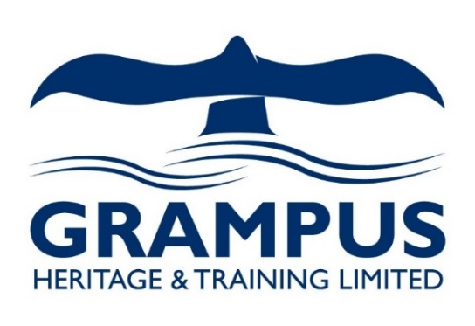

*(A company limited by guarantee)*

Cultural and natural heritage, environmental and land-use project management, consultancy and training

**EITA project – workshop in Cumbria UK (16-22 June 2022)**

**General information**

**Accommodation**: You are going to be located in the historic Market town of Cockermouth. 3 self-catering cottages have been booked in the centre of town with shops and restaurants nearby. It’s a 5 minute walk to Sainsbury Super market). We will be meeting a fixed spot every morning to pick the group up.

My colleague Mark and myself (my number +44 7716533740) will be guiding you during the week and do the airport runs as well.

**A note on the meals.** We will take you food shopping as you stay self-catering accommodation. Most days will need packed lunch prepared by yourself.

**weather**: can be mixed. Warm (20 degrees) and sunny, but also wet and grey. Don’t forget to bring a rain coat and water proof shoes/boots!

**Transport**: hired 14 seater bus

**Programme**

We will spend most days engaging with the local co-operative Wool clip (website: <https://www.woolclip.com/>) which is group of mostly women who are “…using their skills and creativity to make the most of all things wool”, they are located in the lovely village of Caldbeck. The group used to run the local WOOL FEST which was a large market and display of different breed of sheep and wools (which is unfortunately not taking place this year).

The activities will include processing raw wool, felting, dying, peg looming, looking at rare breed sheep and other life stock.

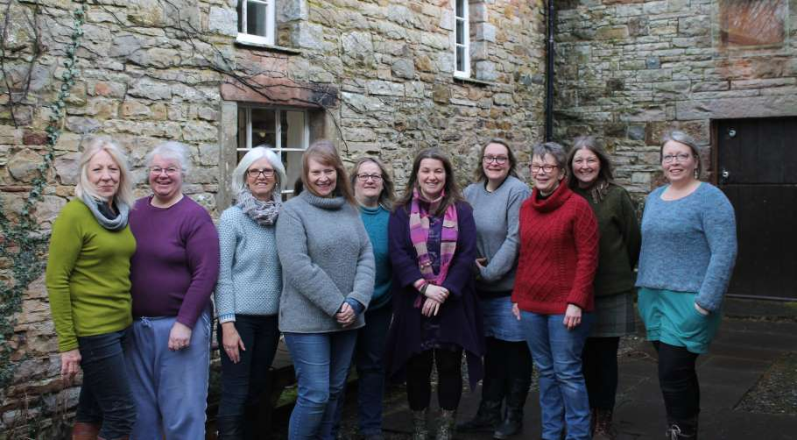

**Pick up point** will be Bitterbeck carpark (behind Market place) which is positioned between the 4 self-catering cottages I have booked for the group. The pink circles mark the cottage locations. The red cross is the meeting point for us. Please be there every morning for the pick up time as stated in the itinerary.

**Thursday 16th June:** arrival day (airport runs and settling in)/ your fridges will be stocked up for you

**Friday 17th June: FARMING DAY** Solid and waterproof shoes needed that day (rain coat just in case)

Pick up 10.15am: Late start because of some participant arriving late the night before

11:00 AM - 1 PM Miller farm (Penruddock) working farm tour and sheep dog demo followed by lunch (farm produced meats) at the farm <https://www.millerfarming.co.uk/>

2pm-4pm: Hannah Scott's small holding (address is Hollow Green, Penrith, CA10 3SG). She owns rare breeds and will show us her sheep, cows and pigs. Including a Afternoon Tea Snack

Drive back to Cockermouth after (will be at least 60 min). Back by 5.30/6pm

**Saturday 18th June** Solid and waterproof shoes needed that day (rain coat just in case)

Pick up 9.45am:We’ll visit Dalefoot compost farm 10.30 They are making Compost from Wool (address Askham, Penrith CA10 2QL). On the way to Askham we will have a short stop at Mayburgh Henge where Mark will give us a quick talk.

<https://www.dalefootcomposts.co.uk/>

1pm: Lunch (soups , drinks and cake) at Mosedale Quaker meeting house. We’ll meet wool clip member Ruth Thompson. .

Then we follow Ruth to Driggeth valley (2miles down the road) and take a walk up a fell (small hill) with Ruth to see where her fell sheep are hefted and learn about Cumbrian hill farming. We’ll learn about the specifics of Cumbrian farming along the hill sides as sheep are left to roam free during the summer.

**Sunday 19th June** Solid and waterproof shoes needed that day (rain coat just in case)

The group will be split into 2 smaller group which will be swapping during the days.

Wool clip member Linda Bennett (The stables, Hutton Moorend, Troutbeck, Penrith, CA11 0SX) will offer an introduction into felting. She produces different items from felt.

Jean Wildish (Tinkers cutting, Penrith. CA11 0FE) will demonstrate how to prepare a fleece (carding and spinning of raw wool).

Pack lunches or eating out: to be confirmed

**Monday 20th June**

Pick up at 9.30 am: We will drive over to **Caldbeck** (30min drive) and look at the Woolclip (shop) where all members present their handmade produce to sell. Followed by a walk up the small Hawk and the bobbin mill and visit Marion Rae’s work shop “rag rug” (peg loom weaving, rag rugging and needle felt embellishments.

Lunch at Water Mill Café above the Wool clip shop.

**Tuesday 21st June**  **Keswick day**

Pick up 9.30am: 10am Keswick Castlerigg Stone Circle and 10.30/11am Keswick Museum visit with tour and introduction into the area

Lunch: We will stop at the famous Keswick Pastry Shop where everyone can pick their choice of pasty and a drink to take away.

After that you have free time in Keswick to look at local small businesses and develop your own impression of the area. In Keswick you will find typical small businesses like Pastry Shop, Fudge Shop, Friars of Keswick (Sweet shop), Keswick puzzle or pencil museum and a large selection if outdoor shops. You can walk through Hope Park to the shore of Derwent Water and enjoy the view at Friars Cragg across the lake into Borrowdale Valley.

We’ll agree a meeting time and point for your pick up later that afternoon.

**Wednesday 22nd June:** departure day (Jessica and Mark will take you back to the Airports)

**P.S. If** there is enough interest and the weather any good I am happy to take you up a fell (local word for mountain) or to lake after “work” one day.

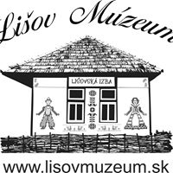  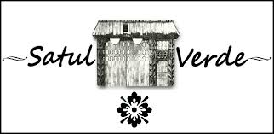

Registered in England No.: 3454114

Registered Office: Ashgill, Threapland, Wigton, CA7 2EL, UK

Telephone: 016973 21516 Fax: 016973 23040 Email: enquiries@grampusheritage.co.uk

Website: [www.grampusheritage.co.uk](http://www.grampusheritage.co.uk)