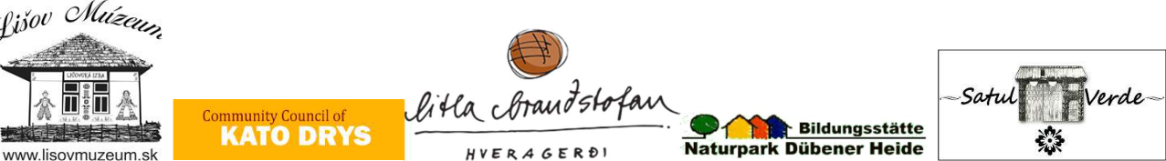
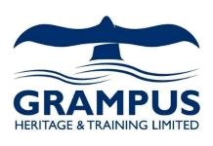


EITA- Exchange of innovative teaching and learning
methods in the craft and service sectors
project number 2019-1-DE02-KA202-006489
Iceland workshop (3th to 9th may 2022)

You will stay at the guesthouse from Helga, Hjarðabol, in South Iceland, on the way from Hveragerði to Selfoss. https://hjardarbol.is/en/

Thuesday 3th may

Arrival of the partners from UK, Romania, Cyprus, Slovakia, Germany
Dinner in Hveragerði

Wednesday 4th may

Breakfast at the guesthouse Hjarðabol
making of icelandic ryebread / we cook/bake it at the hot sping area of Hveragerði
visit at Skyrgerðin Hveragerði (exhibition of skyr-making)
Lunch at Ölverk brewery in Hveragerði
Beer-workshop at geothermal brewery Ölverk in Hveragerði
Dinner at make by the paticipants at the guesthouse

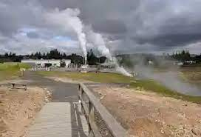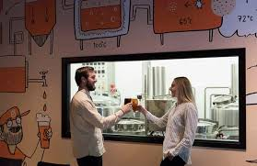

Thursday 5th may

Breakfast at the guesthouse Hjarðabol
Visit at agriculture school of Iceland in Hveragerði
pic up the icelandic bread and visit the Hot Spring Area in Hveragerði
Walk to the hot river in the geothermal area of Hveragerði
Picnic at the hot river, have a bath for those hwo like
Kjötsúpa (Traditional Icelandic Meatsoup) in Reykjadalur Valley
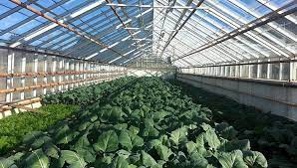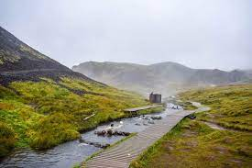

Friday 6th may

Breakfast at the guesthouse Hjarðabol
Skyr-workshop: visit Charlotte at the farm Hvammur and make traditional skyr (icelandic quark/fresh cheese) with Helga in guesthouse Hjarðabol
Lunch in Selfoss, Hvíta Húsið
Wool-workshop (learn about using natural collors from icelandic herbs for colloring wool) at Hesphúsið naer Selfoss
Have a look on Guðjón, hleðslumaður, hwo make walls from lava rocks
Dinner at Hjarðabol make by the participants

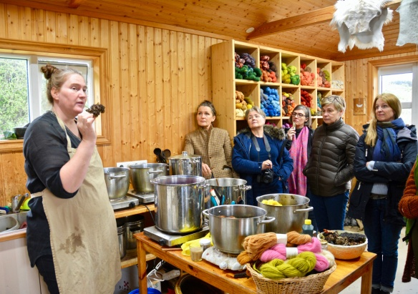

Saturday 7th may

Finnish of the skyr
Breakfast at the guesthouse Hjarðabol, (everyone has the possibility to make his own nesti / lunchpaket for the evening of this day)
Visit of a sheep-farm
Visit at Fríðheimar, icelandic green house in Reykhólt, lunch
Stop at a traditional „réttir“ (circle for to sort sheeps after bringing them back from the highlands)
Visit to Geysir (Hot Spring) and Gullfoss (the golden waterfall)
(Þingvellir) íf we have enough time and energy leftover

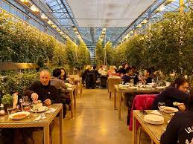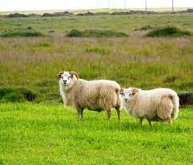

Sunday 8th may

Breakfast at the guesthouse Hjarðabol
Visit LAVA center Hvolsvöllur with stopp at Seljalandsfoss (beautifull waterfall)
Lunch at LAVA center
Departure to the guesthouse and rest of the day at free disposal (such as: Reykjavík / Blue Lagon / Horsebackriding near the guesthouse at Sólhestar)
evening dinner at the guesthouse Hjarðabol

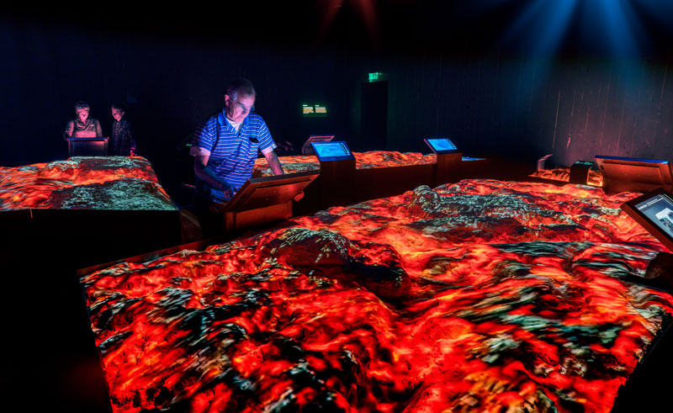

Monday 9th may

Breakfast at the guesthouse Hjarðabol, if possible acording the departure time
Departure to Keflavík Airport / BSÍ (flybus Reykjavík

